Instruction Manual for Voice Controlled using Raspberry Pi

**Installing Required Packages for Bluetooth Communication:**

1. we first need to update the Raspbian using below commands:

**sudo apt-get update**

**sudo apt-get upgrade**

1. Install few Bluetooth related packages:

**sudo apt-get install bluetooth blueman bluez**

1. Reboot the Raspberry Pi:

**sudo reboot**

Finally we need python Library for Bluetooth communication so that we can send and receive data through RFCOMM using Python language:

**sudo apt-get install python-bluetooth**

1. install the GPIO support libraries for Raspberry Pi:

**sudo apt-get install python-rpi.gpio**

1. Pairing devices with Raspberry Pi over Bluetooth

Devices are Android Smart Phone and Raspberry Pi

Open the bluetoothctl utility by below command

**sudo bluetoothctl**

1. Check all the commands of bluetoothctl utility by typing ‘help’. For now we need to enter below commands in given order:

[bluetooth]# power on

[bluetooth]# agent on

[bluetooth]# discoverable on

[bluetooth]# pairable on

[bluetooth]# scan on

1. Make sure that your mobile has Bluetooth turned on and visible by nearby devices. Then copy the MAC address of you device and pair it by using given command:

pair <address of your phone>

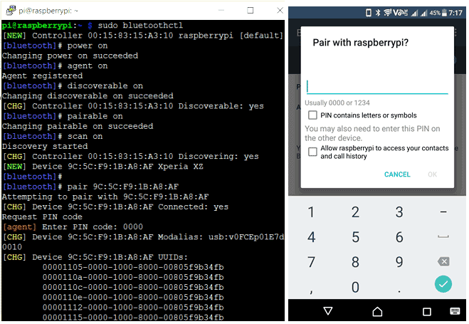

After installing Blueman, you will see a Bluetooth icon in right side of your Raspberry Pi desktop as shown below, using which you can easily do the pairing.

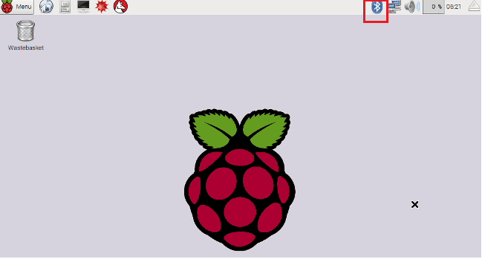

Selecting the Toy Car:

Circuit Diagram and Explanation:

In this Remote Controlled Car, we only need to connect Raspberry Pi with two motors using L293D module. For powering the Raspberry Pi and car we have used a mobile power bank

Schematic:

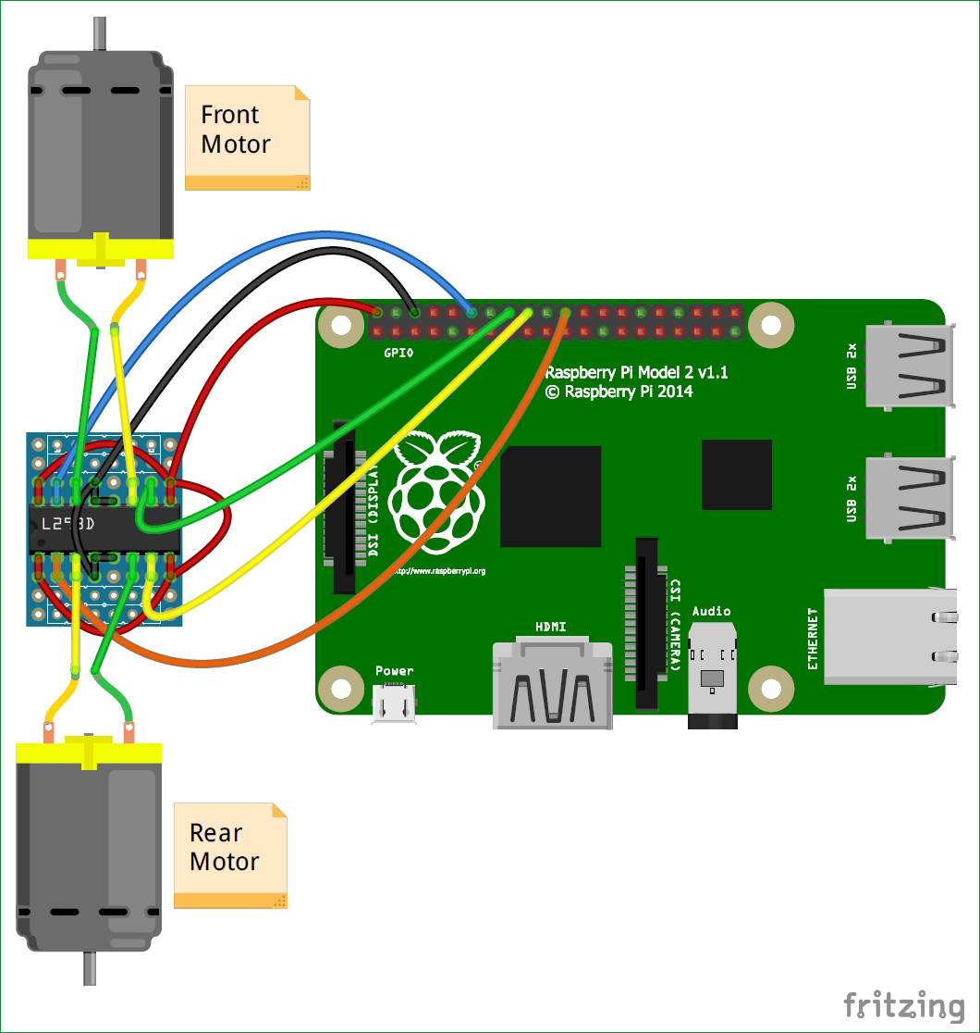

Controlling Car Remotely with Android App BlueTerm:

Now after setting up all the things and successfully try paring the Smart Phone over bluetooth, we need to install an Android App for communicating with Raspberry Pi using a Bluetooth Serial Adapter, so that we can control the GPIO pins of Raspberry Pi

Now after downloading and installing the BlueTerm App, run the below given Python Program from the terminal and connect the paired raspberrypi device from the BlueTerm App at the same time.

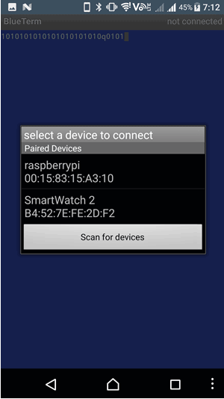

After successful connection you will see connected:raspberrypi at the top right corner of the App as shown below:

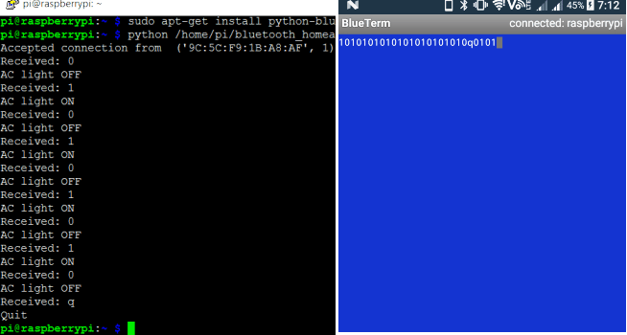

Now you can just enter the following commands from the BlueTerm app to make the car moving in the desired direction. Press ‘q’ to exit the program. You can use Google Voice Typing Keyboard to control this car using your Voice. Check the complete demo in the Video given at the end.

Commands:

F – Move Forward

B – Backward Move

S – Stop

L – Forward Left Move

R – Forward Right Move

A – Backward Left Move

P – Backward Right Move

Q – Quit

**Use Google Voice Typing Keyboard** to control this car using your Voice. Check the complete demo in the **Video** given at the end.